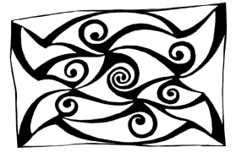
Ulster Place-Name Society Newsletter
November 2019

Seoirse Ó Dochartaigh will give the UPNS autumn lecture, The Clachans of Clonmany, a Parish of Inishowen on Thursday 28th November 2019 at 8.00 p.m. in Room 02/018 of the Peter Froggatt Centre, Queen’s University Belfast. The presentation will be preceded by the Society AGM at 7pm.

Membership Renewal
Members who renew their membership in spring are reminded to do so; the fee is £10/€14 and £15/€20 for institutions. You can now pay your membership online at https://www.ulsterplacename.org/member-details.

Members’ Activities
Kay Muhr gave talks on the Townland Names of Lecale in Downpatrick on Sept 16th (70 attending) and Place-names and Boundaries at an Ulster Local History Trust day conference on Borders and Boundaries in Armagh on October 19th. Kay is continuing her work with Liam Ó hAisibéil on the Oxford University Press publication on the family names of Ireland. Sadly because of time constraints the number of surnames included has to be reduced.

Pat McKay continued to provide Irish-language versions of road names and townland names for Mid-Ulster Council. Kay and Pat both gave presentations at a Community Workshop entitled ‘Field- and Place-Name Interpretation’ in the Craic Theatre, Coalisland on October 23rd. This was the ‘launching pad’ for a local project which will involve local people in collecting and recording hitherto unrecorded place-names.

The Northern Ireland Place-Name Project continues to work through the outstanding townland names. November marks the beginning of the third year of the current phase of research which is funded by the Northern Ireland Department of Finance. To date, provisional analyses (building on work completed in previous phases of the project) have been drafted for Cos Antrim, Armagh, Fermanagh and part of Tyrone. Our focus for the coming year is on completing Co. Tyrone and Co. Derry.

Mícheál Ó Mainnín gave a lecture in the Tower Museum in Derry on 26 September entitled ‘Language, Identity and the Importance of Place-Names’. This was part of the Indigenous lecture series commemorating the International Year of Indigenous Languages.

Micheál Ó Mainnin and Frances Kane gave a talk on ‘Place-names in Lurgan and the North Armagh district: From the Plantation to the Present’ as part of the Lurgan Townscape Heritage (LTH) initiative lecture series.

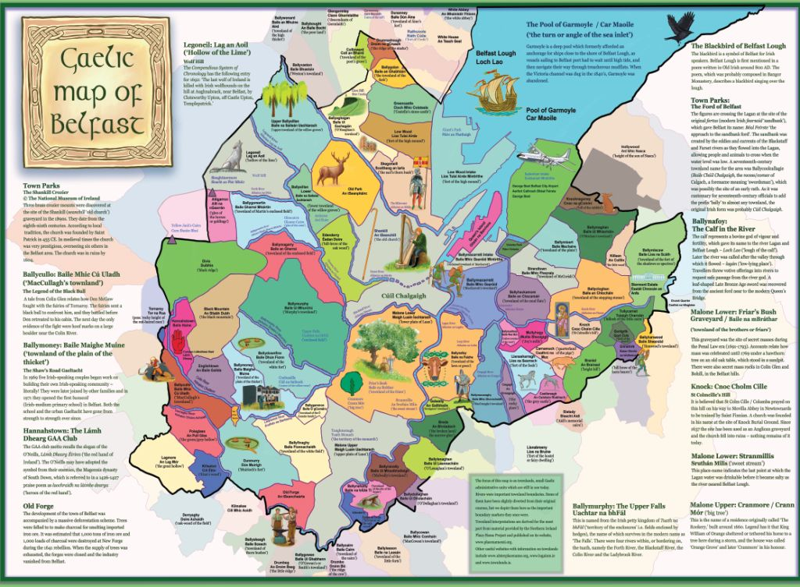
Gordon McCoy persuaded the ULTACH Trust to re-publish 5,000 copies of The Gaelic Placenames of Belfast. The booklet can be downloaded from the Belfast City Council website (belfastcity.gov.uk/community/goodrelations/goodrelations-projects.aspx) and hard copies are available from Gordon at the Skainos Centre: e-mail gordon.mccoy@ebm.org.uk.

Gaelic Maps of Belfast
Gordon McCoy has been working for three years on this project with the artist Andrew Whitson. This work was commissioned by the Good Relations Unit of Belfast City Council and has as its main feature an illustration of the townlands of the Belfast council area, as well as other sites of Gaelic interest. The reverse side has maps illustrating the main centres of the contemporary Irish language scene. The map will be A1 size and will be published soon. Pat McKay is the place-names consultant on the project.

Place-Names Online
There is still time to enter the Northern Ireland Place-Name Project competition to provide a picture of a place-name. Details are at www.placenamesni.wordpress.com/the-competition. Townlands of Ulster (www.townlandsofulster.com) is an attractive website by Karlyn Copper. Using information provided by www.placenamesni.org Karlyn travels to local townlands, taking photographs of interest. Logainm.ie has recently added 827 explanatory notes in English, many of which contain names of trees.

Publications
Seosamh Watson has published a very attractive work, Gleann Cholm Cille: an áit agus a naomh/Glencolmcille/Its places and its saint. This major collection lists 2,500 names, each collected from oral memory, together with surviving historical sources. Each name appears in its authentic Irish form as collected from local informants, along with a definitive interpretation in English and full colour photographs of many of the locations. The work is published by Oideas Gael.

In Scotland, Jake King has edited Scottish Gaelic Place-names: The Collected Works of Charles M. Robertson 1864-1927 (Clò Ainmean-Àite na h-Alba, Sabhal Mòr Ostaig, Skye). The 554 pages include amplified versions of a few published articles, and in Part Two over 8,000 name-forms collected in notebooks during the Revd Robertson’s work as a Gaelic-speaking peripatetic clergyman in the Inner Hebrides and the Scottish mainland (at a time when the language was much more widely used than now).

Annual Deirdre Flanagan Memorial Lecture
The 2019 Spring Lecture, Ptolemy’s Ireland, was delivered by Richard Warner, retired Keeper of Archaeology and Ethnography at the Ulster Museum on the 23rd May 2019 at Queen’s University Belfast. Warner provided an archaeological/geographical/mathematical interpretation of the information on Ireland in the Geographia of Claudius Ptolemaeus, which contrasted with the findings of earlier linguistic interpretations. Although the information was collected in the 2nd century, the earliest copy was discovered by the Byzantine geographer Maximus Planudes in the 14th century. The surviving material consists of a list of places and peoples with longitudinal and latitudinal positions; in reconstructed maps, points are joined with straight lines to create notional coasts.

Many of the names did not survive – scholars attribute this to scribal corruption rather than name change. Warner found the corruption thesis to be untenable, and cited the entries on the ten best copies which differ from one another as follows: 36 letter differences in 4310 letters (1%); 20 location differences in 860 location entries (2%); and 32 of the 58 names show no difference in the ten manuscripts. No names have more than 3 letter differences. Given the lack of difference between the copies Warner dismissed scribal corruption as a significant factor. He also discounted the linguistic gymnastics and complex mathematics which were employed to correlate Ptolemy’s list with known names.

If we superimpose a map of Ireland onto Ptolemy’s information, allowing for the fact that he thought that the earth was 18% smaller than it is, and if we adjust the rotation slightly, it is possible to identify three key points from which many others were mapped: Logia ( Belfast Lough), Buwinda (the Boyne) and Ieron (‘sacred’) Point ( Carnsore Point).

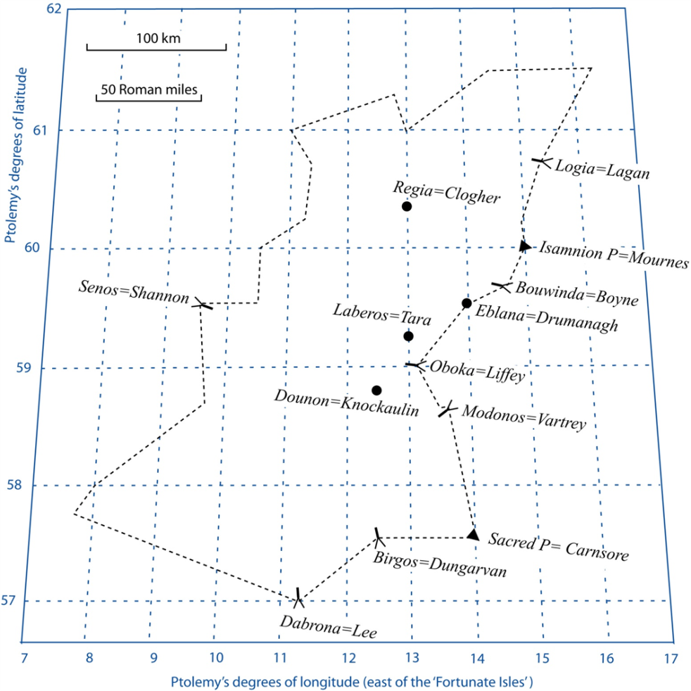
Warner discounted O’Rahilly’s theory that Isamnion was Navan; it is clearly a coastal promontory that corresponds with the Mourne
Mountains. He quoted De Bernardo Stempel to interpret the inhabitants as *Isamnioi, meaning ‘people who are under’ or ‘underworld folk’. Ptolemy’s information was collated when Roman artefacts were being brought to Ireland during the 1st and 2nd centuries, and Warner identified a number of sites where such artifacts were discovered: Winderis = Dundrum Bay; Edros = Howth; Regia (‘royal place’) = Clogher; Laberos = Tara; Dounon = Knockaulin fort; and Eblana = Drumanagh fort. In terms of rivers and inlets, he finds that Oboka = River Liffey; Modonou = River Vartry; Darona = River Lee and Birgos (a name related to the Brigantes) = Dungarvan Bay. In the west Warner identifies the River Senos as the Shannon, but it is out of place and most of Ptolemy’s western points cannot be identified.

Gordon McCoy, Mícheál Ó Mainnín, Greg Toner, Kay Muhr, Pat McKay, UPNS c/o Irish and Celtic Studies, School of Modern Languages, QUB BT7 1NN

Email: townlands.upns@gmail.com
Website: www.ulsterplacename.org
See also: www.placenamesni.org and www.logainm.ie

